WAYS OF USING SONGS IN EFL CLASSROOM

Limba engleză-clasele gimnaziale
Szőcs Réka
TABLE OF CONTENTS

WAYS OF USING SONGS IN EFL CLASSROOM ………….….…….…….………1
1. Building the Song ……………………………………….………….……….……..2
2. Oral Song Project - oral presentations ………………….………..….…….……….4
3. Contrasting two styles or themes ………………………….……………….………4
4. Ear training and pronunciation ……………………….……………….…….……..4
5. Closing or filling the gap ………………………….………………….….….……..6
6. Spot the mistakes …………………………….…………….…………..…………..8
7. Mixed activities ………………….…………………………………….…………...8
8. Discussion …………………….……………………………………………………8
9. Activities A-B ………………………………………………………………………8
10. Reading activity …………………………………………………………………...9
11. Composition …………………………………………………………………..…..11
12. Writing ……………………………………………………………………… …..11
References …………………………………………………………………...…… …13

WAYS OF USING SONGS IN EFL CLASSROOM

Our country is different and our language is different. Splashing in the sea of ​​music, however, we can always communicate in a world language.
Maryanna

Researchers claim that music has a positive impact on basic language skills, helping to develop verbal memory and vocabulary. I am sure you already know what a powerful positive impact music has on English language learners. Just as movies in their original version help us understand English more easily, the lyrics of our favourite songs are an important source of easy-to-memorize words and phrases, and that is simply because we enjoy it.
Linguists claim that this method is useful because music and language are closely related. This was proven by a study by ACTA Otorhinolaryngologica Italica, the Official Journal of the Italian Society of Otorhinolaryngology. The research collected data on the results of English, French and Music lessons from 502 secondary school students in an Italian school. The results showed a significant correlation between scores in the two foreign languages ​​and music, reflecting the potential impact of neurophysiological theories connecting music and language processing pathways.
Another research on the benefits of music for children is conducted by the Max Planck Institute for Psychologists and suggests that both language and music processing are associated with the same part of the brain, called Broca's area, which is located in the left hemisphere. This area is very important for language learning because it controls our ability to arrange words into sentences and phrases so that they make sense.
Because music is made up of notes and chords, and language is made up of sounds and words, the two are related. Well, when they are also combined, they become a perfect learning tool through English children's songs. Looking at the similarities between language and music, it is no wonder that they can complement each other perfectly.
What makes a successful song-based lesson? Adam Simpson, second-time winner of the British Council’s Teaching English blog award for his post on conditionals (written with Paul Mains), explains.
“One of the big problems we all face, whether teaching English to children or adults, is maintaining learners’ interest throughout our lessons. Consequently, we often have to be very creative in the techniques we use. What makes music such a great teaching tool is its universal appeal, connecting all cultures and languages. This makes it one of the best and most motivating resources in the classroom, regardless of the age or background of the learner.”
There are lots of useful exercises that can be built around songs to help your learners' development in the acquisition of English as a foreign language. In the following I would like to show the ones I have tried before.

- Building the Song

One of my favourite songs is Last Christmas by Wham.
https://www.youtube.com/watch?v=E8gmARGvPlI
Song backround: Released in 1984, this was the biggest selling single in history to never reach Number One in the British charts – despite selling well over a million copies.
First, I write the following words on the board:
again apart away been cry day eye eyes heart ice meant recognise rely sent shy surprise tears year
Students match the rhyming pairs. Note: More than one rhyming pair may be possible for some words, but this is not a problem at this stage.
Key: heart-apart, again-been, day-away, year- tears, shy-eye, ice-eyes, recognise-surprise, sent-meant, cry-rely

Then, I write the lyrics in verses/stanzas on strips of paper. I put students into groups, each of them receives a verse/stanza. Together they have to “build” the song. Then they listen to it and check their solutions.
Here are the verses/stanzas of the song:

Last Christmas – Wham!

Last Christmas I gave you my heart,
But the very next day you gave it away.
This year, to save me from tears,
I'll give it to someone special.

Once bitten and twice shy.
I keep my distance, but you still catch my eye.
Tell me baby, do you recognise me?
Well, it's been a year, it doesn't surprise me.

"Happy Christmas" I wrapped it up and sent it
With a note saying "I love you", I meant it
Now I know what a fool I've been
But if you kissed me now, I know you'd fool me again.

Last Christmas I gave you my heart,
But the very next day you gave it away.
This year, to save me from tears,
I'll give it to someone special.

Crowded room, friends with tired eyes.
Hiding from you and your soul of ice
My Gosh, I thought you were someone to rely on
Me? I guess I was a shoulder to cry on.

Face on another with a fire in his heart.
A man under cover but you tore me apart.
Ooh, ooh, now I've found a real love,
You'll never fool me again.

Last Christmas I gave you my heart,
But the very next day you gave it away.
This year, to save me from tears,
I'll give it to someone special.

- Oral Song Project - oral presentations

I use this type of activity with students at intermediate level. It requires more time, but it can be very motivating. Students in pairs or in small groups choose a singer or genre of music. They prepare an oral presentation, including song extracts, a biography of the singer/band and a description of the instruments used.

- Contrasting two styles or themes

I choose two songs that cover a similar theme to compare and contrast. For example, I choose the topic “friendship”: Count On Me by Bruno Mars and Stand By Me by Ben E. King. Students are divided into 2 groups and each of them listens to a different song and prepares a presentation of the song. After the presentations, I follow up with a discussion on the same topic.
https://www.youtube.com/watch?v=4JNtAtGGNRU
https://www.youtube.com/watch?v=dTd2ylacYNU

- Ear training and pronunciation

First, I choose a song which has a lot of rhymes. Then I remove all the rhyming words. I give the students those words on a piece of paper or on the board. Students have to match the rhyming words, after that they try to guess what the song might be about.
Then they listen to the song and they put the rhyming ending words in order as they hear them. In the end I hand out a sheet with the lyrics and they fill in the missing rhymes.
For example: Super Trouper by ABBA
https://www.youtube.com/watch?v=BshxCIjNEjY
Super trouper beams are gonna blind me
But I won't feel blue
Like I always do
'Cause somewhere in the crowd there's you
I was sick and tired of everything
When I called you last night from Glasgow
All I do is eat and sleep and sing
Wishing every show was the last show (wishing every show was the last show)
So, imagine I was glad to hear you're coming (glad to hear you're coming)
Suddenly I feel all right (and suddenly it's gonna be)
And it's gonna be so different when I'm on the stage tonight
Tonight, the super trouper lights are gonna find me
Shining like the sun (super trouper)
Smiling, having fun (super trouper)
Feeling like a number one
Tonight, the super trouper beams are gonna blind me (super trouper)
But I won't feel blue (super trouper)
Like I always do (super trouper)
'Cause somewhere in the crowd there's you
Facing twenty-thousand of your friends
How can anyone be so lonely?
Part of a success that never ends
Still I'm thinking about you only (still I'm thinking about you only)
There are moments when I think I'm going crazy (think I'm going crazy)
But it's gonna be alright (you'll soon be changing everything)
Everything will be so different when I'm on the stage tonight
Tonight, the super trouper lights are gonna find me (super trouper)
Shining like the sun (super trouper)
Smiling, having fun (super trouper)
Feeling like a number one
Tonight, the super trouper beams are gonna blind me (super trouper)
But I won't feel blue (super trouper)
Like I always do (super trouper)
'Cause somewhere in the crowd there's you
So I'll be there when you arrive
The sight of you will prove to me I'm still alive
And when you take me in your arms and hold me tight
I know it's gonna mean so much tonight

- Closing or filling the gap - www.teachingenglish.org.uk

This is one of the most often used activity. Depending on what I teach, I choose and take out all the words belonging to a certain category, such as prepositions, verbs, tenses. Normally seven or eight.
For example, when I teach or practice the present simple tense, I often use the song Shallow by Lady Gaga and Bradley Cooper.
https://www.youtube.com/watch?v=JPJjwHAIny4
Tell me something, girl
1 .…….. you happy in this modern world?
Or 2 …… you need more?
3 ……… there something else you're searchin' for?
I'm falling
In all the good times, I 4 ………. myself longin' for change
And in the bad times, I fear myself
Tell me something, boy
Aren't you tired trying to fill that void?
Or do you need more?
Ain't it hard keeping it so hardcore?
I'm falling
In all the good times, I 5 ……….. myself longing for change
And in the bad times, I 6 ……….. myself
I'm off the deep end, watch as I ………… in
I'll never meet the ground
Crash through the surface, where they can't hurt us
We're far from the shallow now
In the sha-ha, sha-ha-llow
In the sha-ha-sha-la-la-la-llow
In the sha-ha, sha-ha-llow
We're far from the shallow now
Oh, ha-ah-ah
Ah, ha-ah-ah, oh, ah
Ha-ah-ah-ah
I'm off the deep end, watch as I dive in
I'll never meet the ground
Crash through the surface, where they can't hurt us
We 7 ………… far from the shallow now
In the sha-ha, sha-ha-llow
In the sha-ha-sha-la-la-la-llow
In the sha-ha, sha-ha-llow
We're far from the shallow now

KEY. 1. Are 2. do 3. Is 4. find 5. find 6. fear 7. are

If it is necessary, I give vocabulary clues or synonyms for the missing words and I have students work in pairs to predict words before listening the song.

- Spot the mistakes

Most students enjoy this activity a lot. I change some of the words in the lyrics and as students listen, they have to spot and correct the mistakes. For example, if I teach the Present Simple Tense, the song Another Day in Paradise by Phil Collins can be a very good choice.
https://youtu.be/eaFlJQGtBeM?feature=shared&t=21

- Mixed activities

I have the lines of the song on separate strips of paper. Students try to guess the correct order of the lines. Later, they listen to the song and check if they were right.

- Discussion
Before leading into a discussion on a certain topic, I often use songs to pre-teach vocabulary.
The Best Day by Taylor Swift is a good example to lead into a discussion about family.
https://www.youtube.com/watch?v=n0cde-Km05o

- Activities A-B

In this activity students match the beginning and end of the lines.
I use the song the song I Will Always Love You by Whitney Houston:
https://www.youtube.com/watch?v=3JWTaaS7LdU

Verse 1:
If I should but I know
I would only be you
So I'll go stay
I'll think of the way
Every step of in your way
Verse 2:
Bittersweet please don't cry
That is all memories,
So goodbye, I'm taking with me
We both know I'm not what you, you need

Verse 3:
I hope life treats for you joy, and happiness
And I hope you have
All you've dreamed of
And I wish you kind
But above all this, I wish you love.

- Reading activity

This is a lead-in activity. Students read the biography of the singer and solve some tasks related to the text, like in the example below.

- Read Phil Collins’ biography and answer the questions.

Phil Collins spent most of his early life as a young actor, and played the Artful Dodger in the West End production of "Oliver!" His interest in music and drumming began at school, where he became the drummer in the school band called The Real Thing. His next band was Flaming Youth. Collins later successfully auditioned for Genesis, taking over on vocals from Peter Gabriel in 1975.
After separating from his first wife, Collins recorded his first solo LP, "Face Value". The album was well received, and Collins became a household name after the song "In the Air Tonight" which was featured in the American TV series "Miami Vice". He then had a guest appearance in the series, playing a game show host. His third LP, "No Jacket Required", produced multiple chart hits and won many awards.
Collins continues to be an active musician and entertainer, producing and guesting on many albums, ranging from Gary Brooker and Camel (Peter Frampton's old band) to Eric Clapton. His current projects include his solo career as a vocalist, and touring with the reunited Genesis and his Swing Band.
a) What did Collins do before becoming a musician? _________________________________
b) What instrument does he play?_____________________________________________
c) What was the name of his first band?________________________________________
d) In which band did he replace Peter Gabriel on vocals?___________________________
e) What was the name of his first solo album? __________________________________
f) In which TV series did he guest as a game show host?___________________________

2. Match the following phrasal verbs to their meaning.
1. call out a. continue walking
2. walk on b. know something because of certain signs
3. look back c. say something loudly to someone
4. can tell from d. leave a place you have been staying and continue to another place
5. move on e. turn your head around in order to see something

www.tuneintoenglish.com
After that, a good follow up interactive activity can be done on Wordwall.
https://wordwall.net/resource/73408132/another-day-in-paradise-by-phil-collins

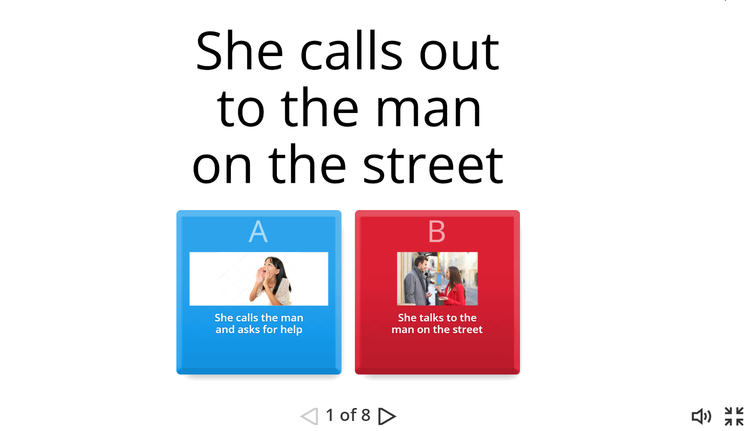
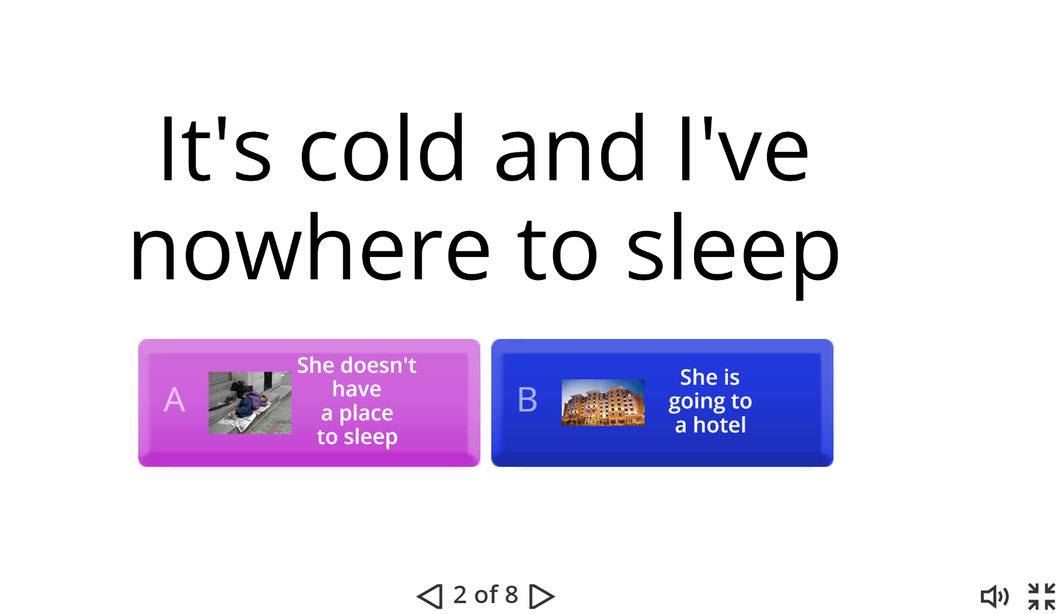
www.wordwall.net
- Composition
I give the students the lyrics of the song and they add their own verses. A very good song for this is Imagine by John Lennon.
After that they guess the endings/missing words by doing an interactive activity on Wordwall.
https://wordwall.net/resource/73401080/imagine-by-john-lennon
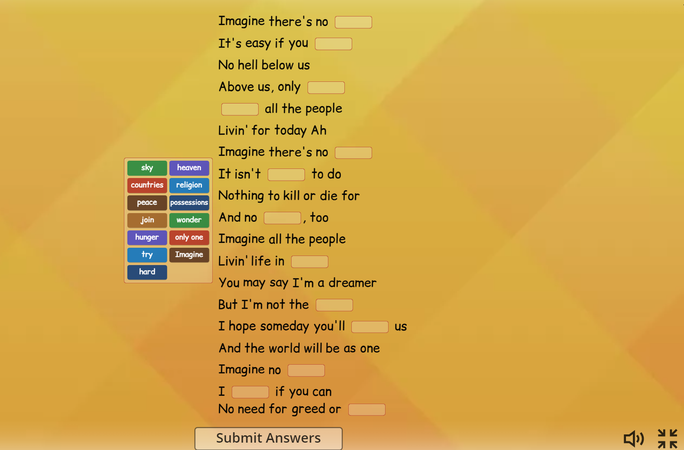
www.wordwall.net
11. Writing
In this activity students work in groups. I put random words from the song on the board. Students try to write the "song story", then they paraphrase the song.
Another way is to cut the song in half and students predict the other half.

* * *

One of my favourite songs that I use in my classrooms is Ed Sheeran's Perfect. It is a 2017 hit, a true pop song, which approaches a relationship from a physical point of view rather than internal qualities or personality. The song basically consists of verses and choruses, it is a slow song so the learners of different levels could easily work with the lyrics.
I created an interactive activity on Quizizz, which can be done at school or assigned as homework.
https://quizizz.com/print/quiz/6627bd3b9e2953090cbc99f6?source=worksheet_share
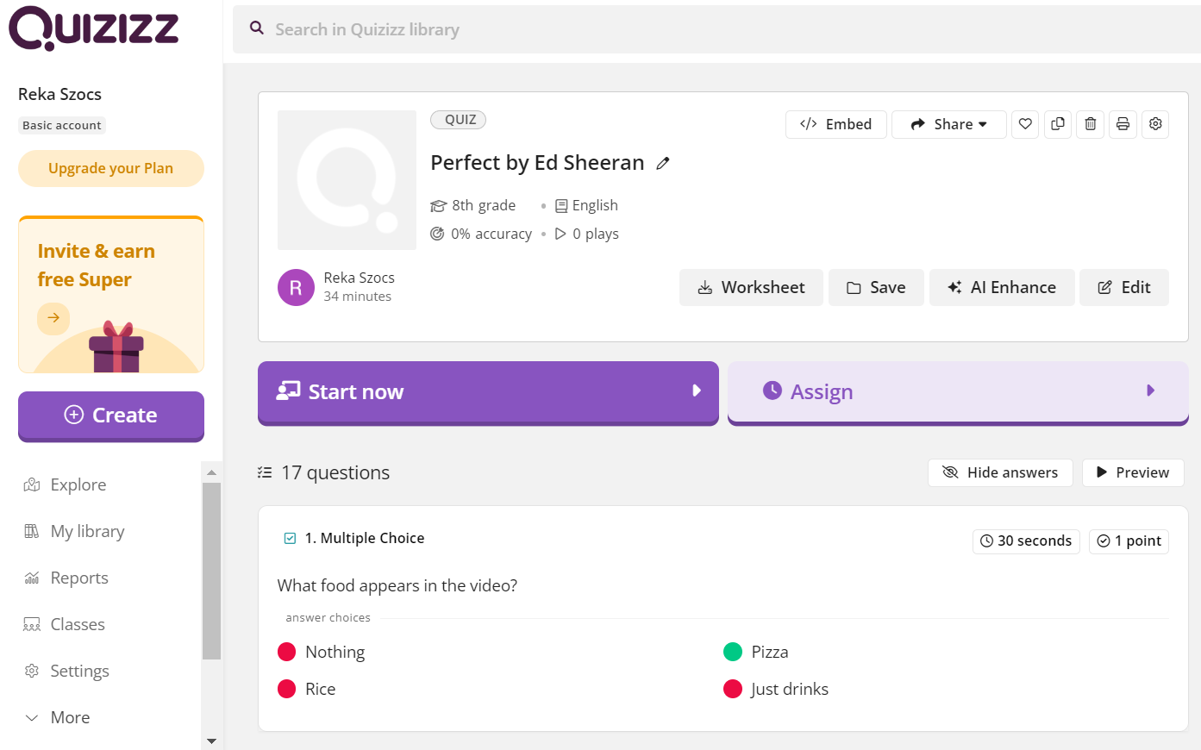
Songs can be used as a valuable teaching and learning tool. Using songs can help learners improve their listening skills and pronunciation; they can also be useful for teaching vocabulary and sentence structures. Probably the greatest benefit to using songs in the classroom is that students really enjoy them.

References

Baoan, W.: (2008) Application of popular English songs in EFL classroom teaching, Humanising Language Teaching.
Graham, C.: (1992). Singing, Chanting, Telling Tales, New Jersey, USA: Prentice Hall.
Griffe, D. T.: (1992), Songs in Action, Hertfordshire, England: Prentice Hall.
McKay, P.: (2006), Assessing Young Language Learners, Cambridge, Cambridge University Press
Purcell, J. M. (1992). Using songs to enrich the secondary class. Hispania

Webography

www.freeplaymusic.com
www.ohhla.com
www.mtv.com
www.tuneintoenglish.com
www.wordwall.net
www.quizizz.com
www.britishcouncil.org
www.youtube.com

