Materiale digitale
Autor: Kinda Eleonora
Platformele: LIVRESQ şi Bookcreator

- LIVRESQ
Denumirea materialului digital:
- A Nagyhét eseményei (Evenimentele din Săptămâna Patimilor)
https://library.livresq.com/details/61f82a7b2d4428000a6fea64

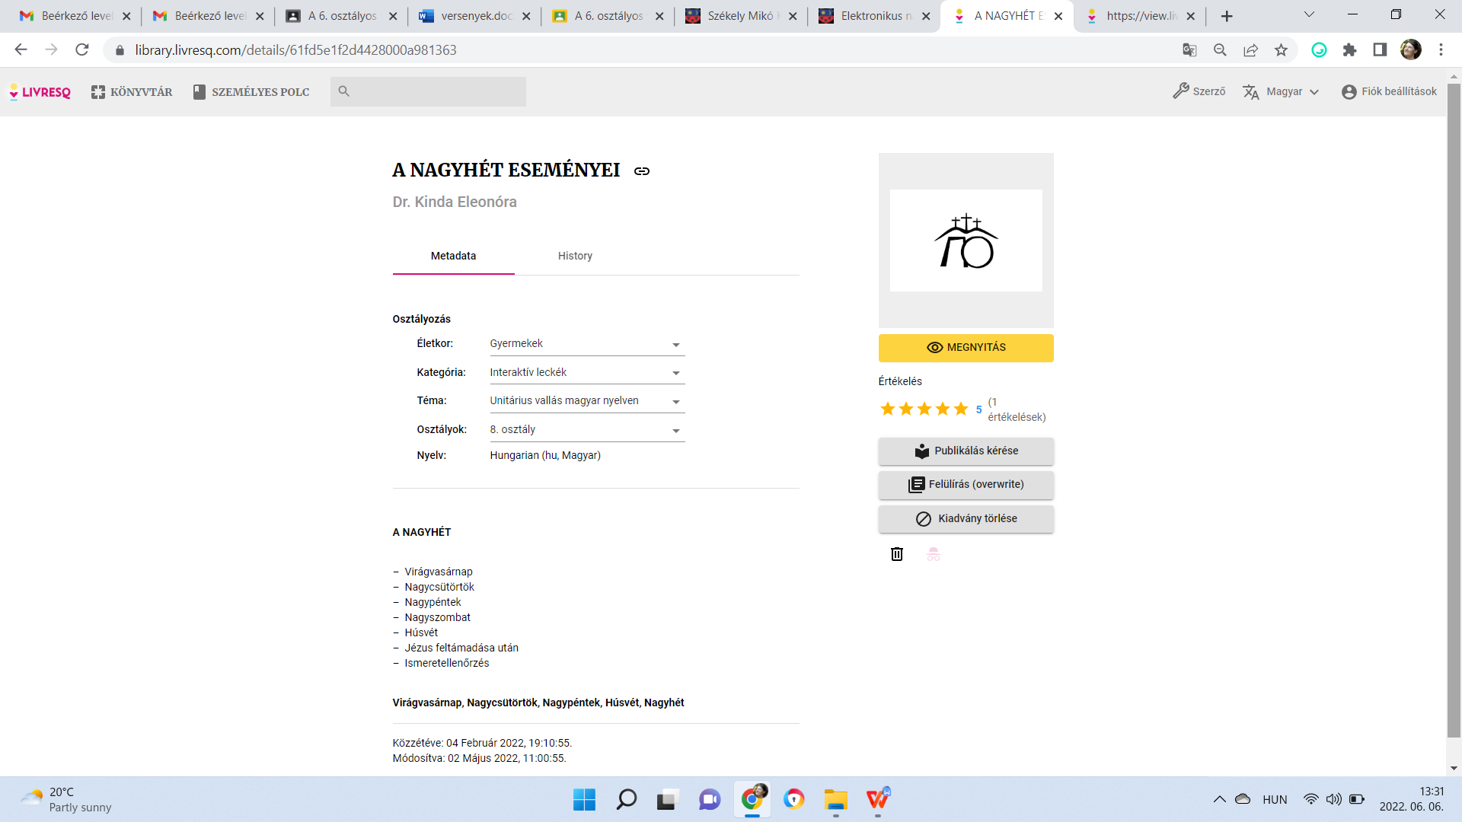

Denumirea materialului digital:
- A Reformáció (Reforma bisericii)
https://library.livresq.com/details/5fd7881b4395010007a5d78f

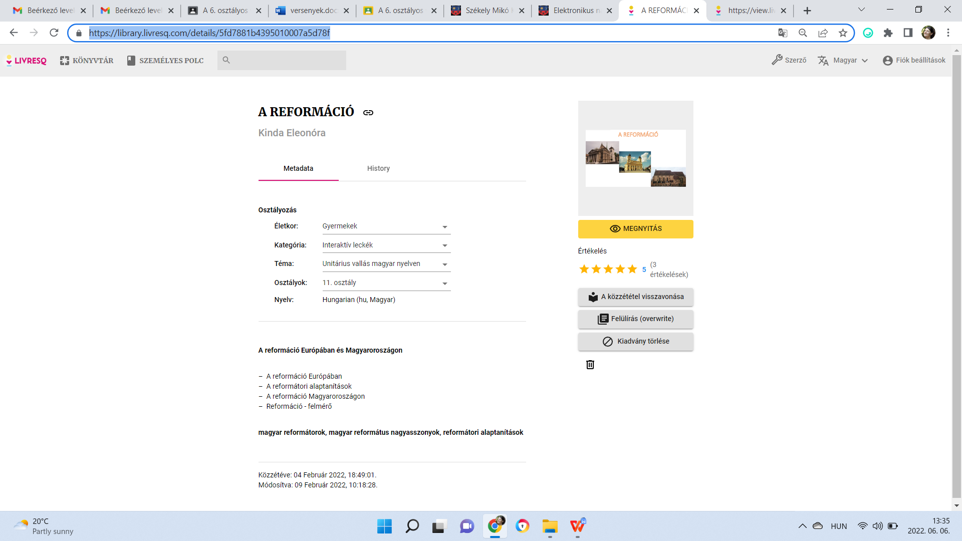

Denumirea materialului digital:
- Előreformátorok
https://library.livresq.com/details/61f827a22d4428000a6fbed5
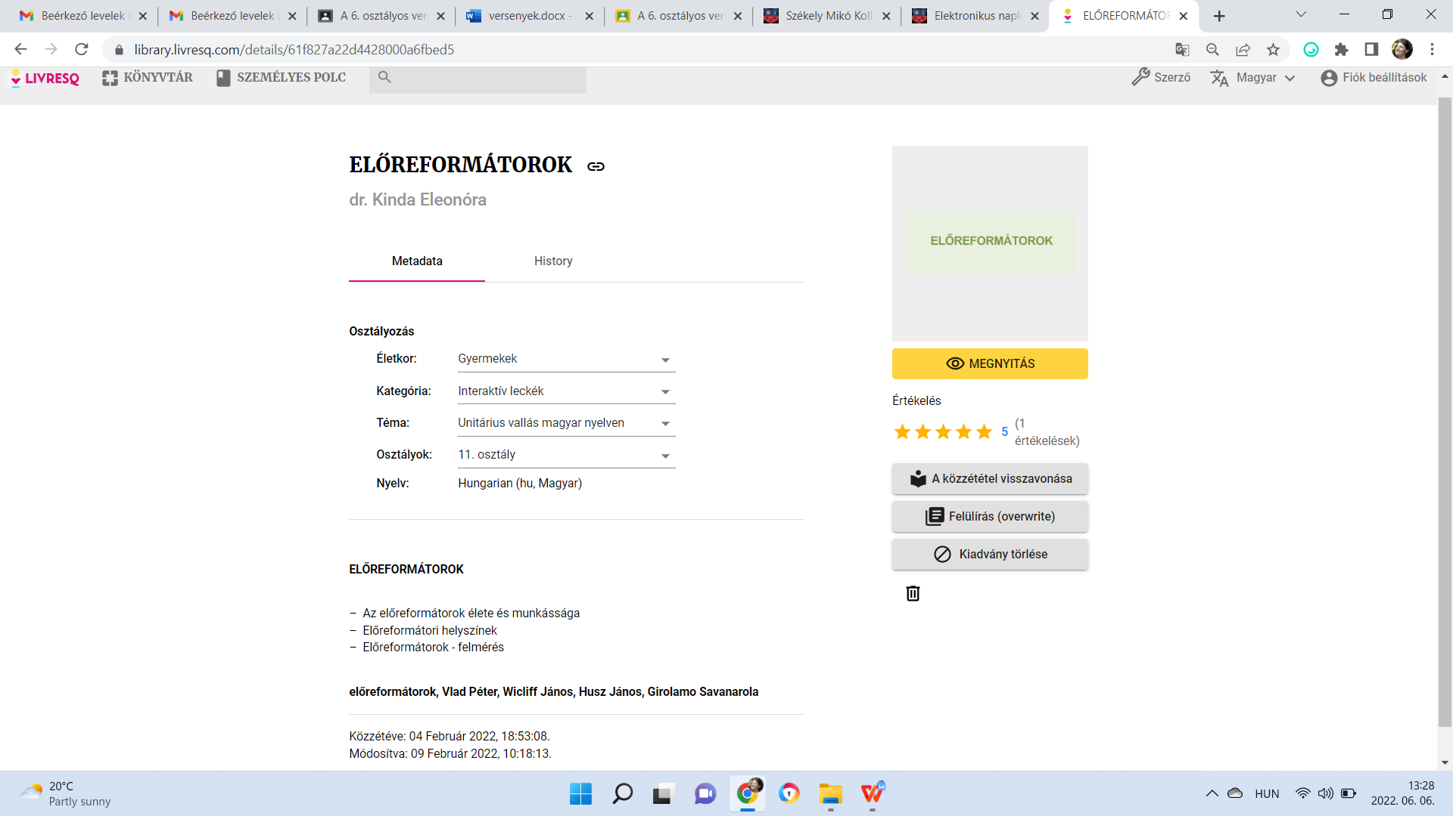

- BOOKCREATOR
Denumirea materialului digital:
- A teremtés története (Crearea lumii)
https://read.bookcreator.com/rgumqIfWtmdrITYGoZY8NBrmCdD3/u3KGSYtoQ-q0-K2yuBaj1g
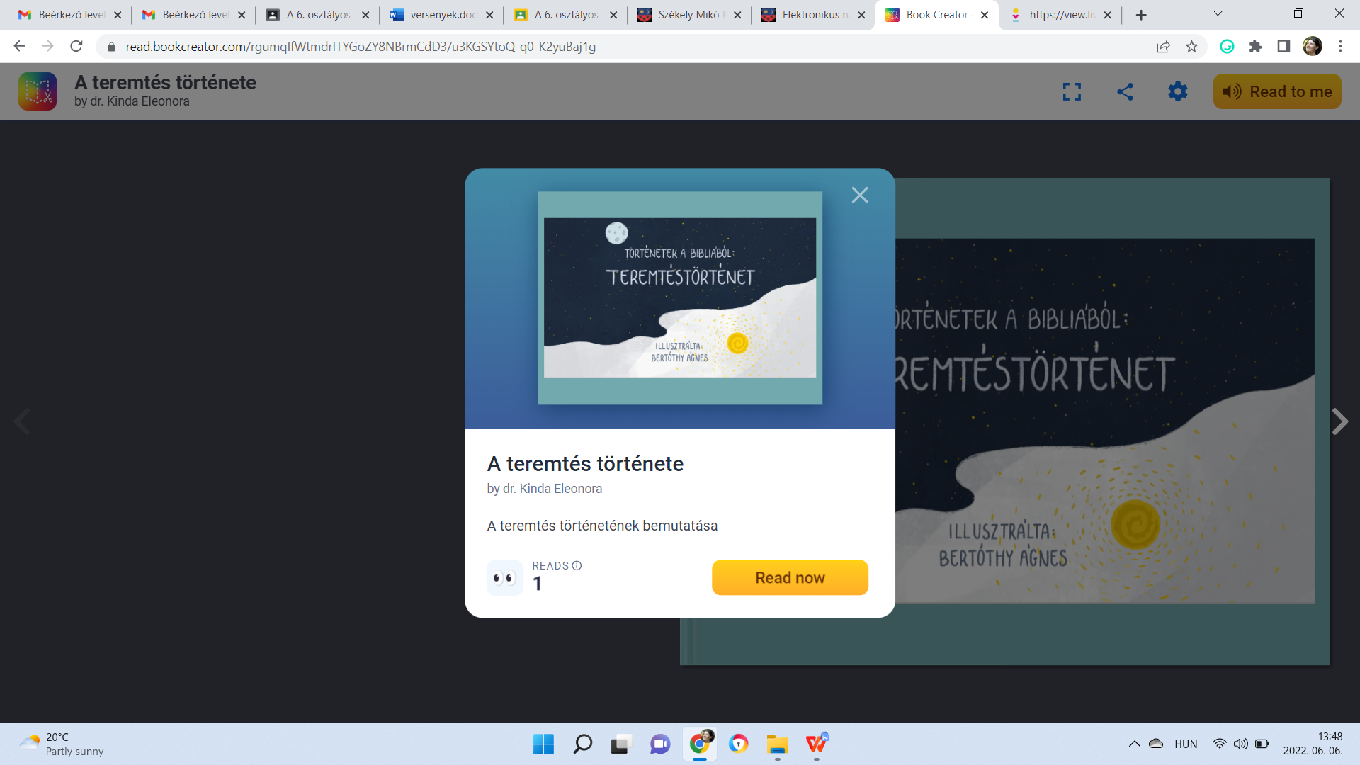

Denumirea materialului digital:
- Ádám és Éva (Adam şi Eva)
https://read.bookcreator.com/rgumqIfWtmdrITYGoZY8NBrmCdD3/035nyHyCSWi--e-L8VM26g
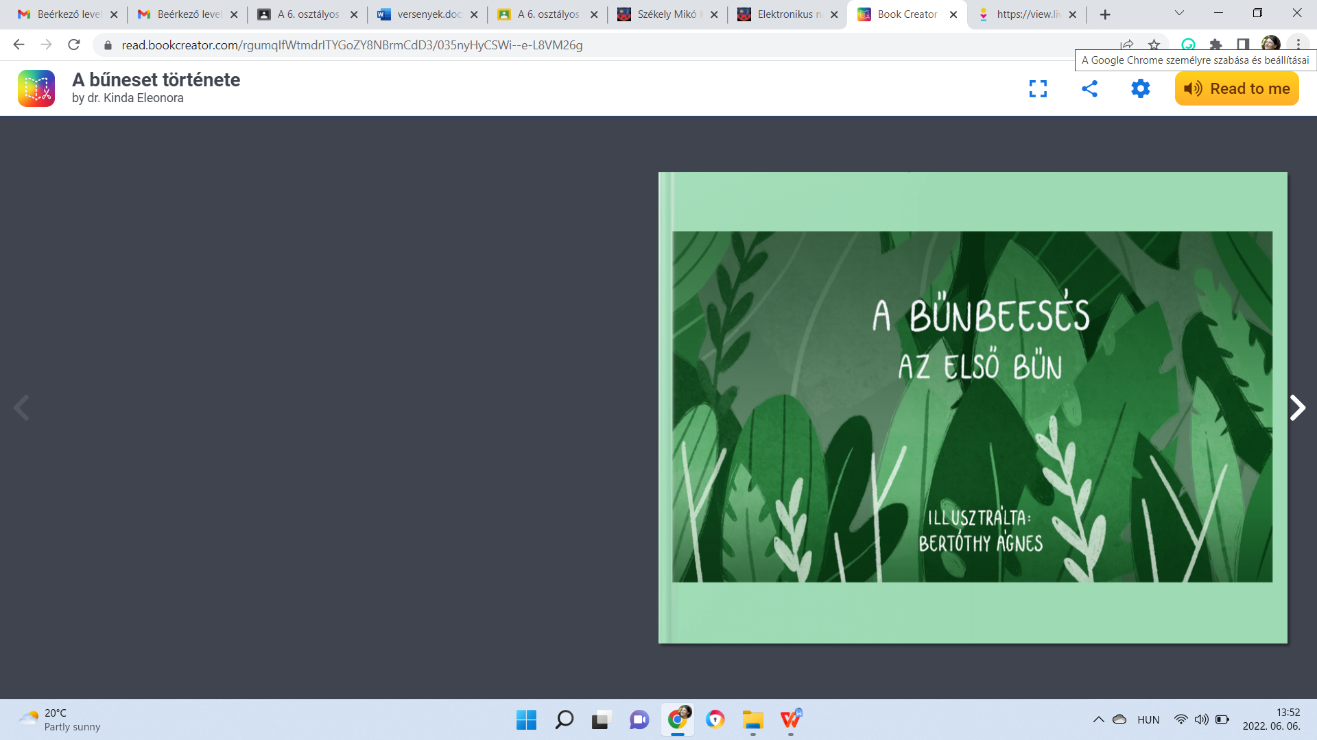

Denumirea materialului digital:
- Jézus Krisztus születése (Naşterea lui Iisus)
https://read.bookcreator.com/CfJqNvH90SevPJCn566vj2a9tJs2/k0_kDKPEQDGw7MDVcKNoKw

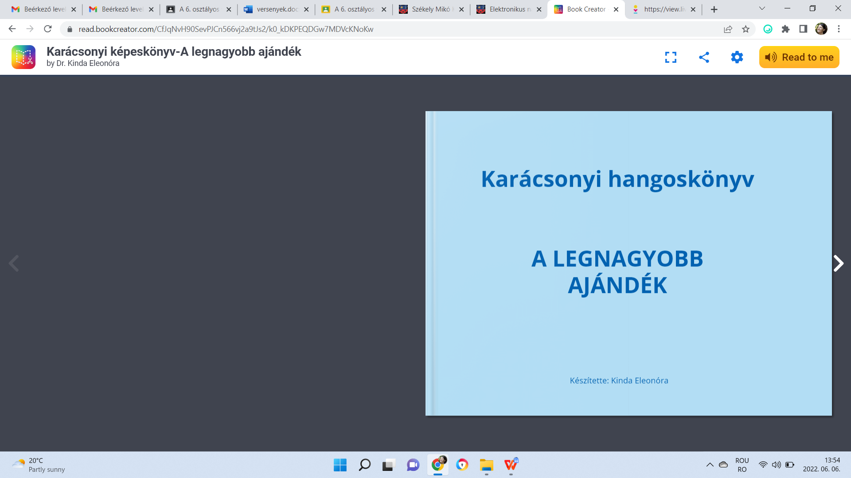

Denumirea materialului digital:
- Jézus tanítványai (Ucenicii lui Iisus)
https://read.bookcreator.com/CfJqNvH90SevPJCn566vj2a9tJs2/B4evlaNXSVavAPM0QgiQcg

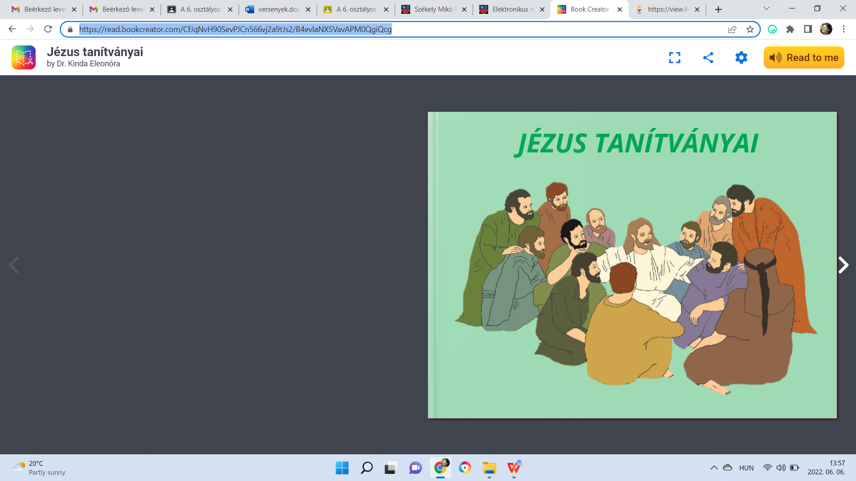

Denumirea materialului digital:
- A pünkösd ünnepe (Rusaliile)
https://read.bookcreator.com/rgumqIfWtmdrITYGoZY8NBrmCdD3/c4h2VisURZW0WStuSgN5ZA

