Kim’s house
Worksheet
1. Read the following text and answer the questions:
Kim lives in a beautiful house. It is quite large and comfortable. It is air-conditioned and well-furnished. Downstairs there is a kitchen, a big living room, a nicely furnished dining room, a study room, and a bathroom. Upstairs, there are four bedrooms, two bathrooms and a big balcony. The rooms are well lighted and airy. The living room is decorated beautifully with paintings by famous artists and pictures. At night, the color neon lights increase the beauty of the room. There, on Sundays and holidays Kim’s father usually spends his time playing chess or drinking tea with his friends. Each room has beautiful curtains. All the furniture in the house is new.
The open terrace is in front of the flower garden. This makes her house more beautiful. Backyard, Kim’s parents have a vegetable garden. There they grow tomatoes, peppers, lettuce, cucumbers and carrots. They daily water the plants in the garden. There is a garage next to the house. Behind the garage there is a swing. Kim and her brothers like playing on the swing. In the living room, there is a big sofa and two armchairs. There is a carpet and a small round table in front of sofa. The children watch TV or have some popcorn in the living room every evening.
Kim’s house is tastefully decorated and all the members keep the house neat and clean. She loves her house very much because it is the place where she was born and grew up in the education of her father and in the tender loving care of her mother. She spent her whole childhood in the love and affection of her dear ones with so many sweet memories.
- Where does Kim live?
- Where can you find the 2 bathrooms?
- Is the house decorated?
- Is the furniture old?
- What is in front of the flower garden?
- What vegetables do Kim’s parents grow?
- Where is the swing?
- What do children eat every evening?

2. Decide if the sentences are True or False:
a. Kim doesn’t live in a beautiful house.
b. The kitchen is downstairs.
c. The furniture in the house in new.
d. The open terrace is behind the flower garden.
e. There is a square table in the living room.

3. Write the names of the rooms that you can see in the picture. Use the text to find them!!!!
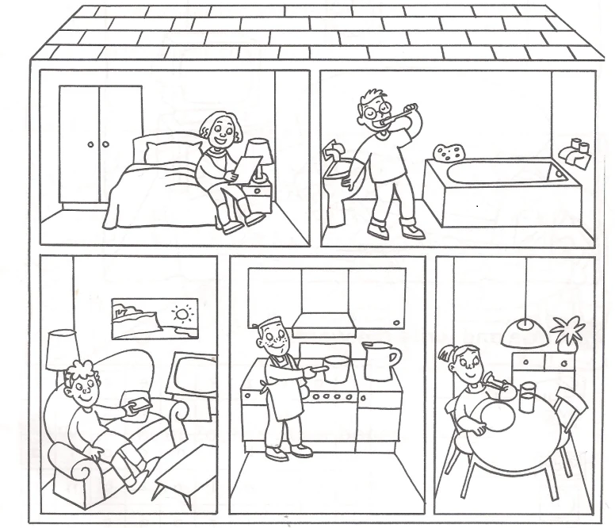
3.
4.
5.
1.
2.

4. What does your house look like? Write a description of it in 100 words.

Key:

- Kim lives in a beautiful house.
- The two bathrooms are upstairs.
- Yes, it is.
- No, it isn’t.
- The open terrace is in front of the flower garden.
- Kim’s parents grow tomatoes, peppers, lettuce, cucumbers and carrots.
- The swing is behind the garage.
- Every evening children eat popcorn.

2. a- F, b- T, c-T, d- F, e- F
3. 1. Bedroom, 2. Bathroom, 3. Living room, 4. Kitchen, 5. Dining room

