Fişă de lucru

Read the two stories about Alexander the Great and fill in the correct form of the verb in brackets. Use active or passive voice.

Two things you (probably) didn’t know

about Alexander the Great

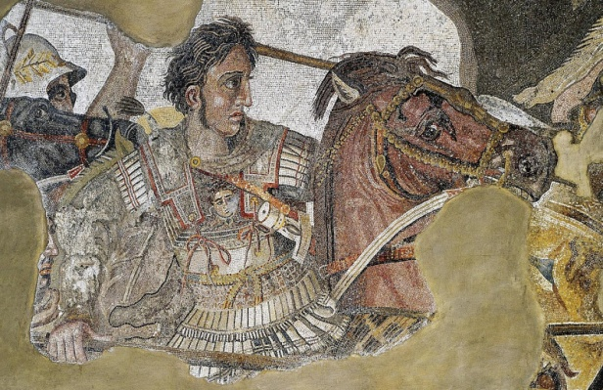
Up in knots
Of all the heroics, real or mythical which 1……………. (attribute) to Alexander, one of the most famous is how he 2………….(loosen) the Gordian Knot. This 3…….(be) a leather knot, of the most complex kind which 4………...(find) on an ancient ox cart around the Temple of Zeus in the city of Gordion (in modern-day Turkey).
A former king, Gordius, 5………….(leave)the cart there and legend 6………..(foretell) that whoever managed to loosen the knot would rule all of Asia.
Various sources claim that Alexander 7………….(untie) the knot but none makes it clear how he 8…………..(do)so. Some believe he simply 9……….(slash) it with his sword.

The polo player
Legend has it that when Alexander the Great was about to invade Persia in 334 BC, the Persian King Darius III ………..10(send) him a polo mallet and ball. It ………...11(think) that this gesture was either inviting the Macedonian to a game, or he 12…………(suggest) that Alexander should “stick to games and avoid war”. Whatever the intention, Alexander is said to have replied: “I am the stick and the ball is the Earth” – before going on to conquer Persia.
Polo, one of the oldest sports in the world, likely 13……..(originate) somewhere in Central Asia. Mounted nomads played a version of polo that was part sport, part training for war, with as many as 100 men on a side. If its origins are obscure, there is ample evidence of the game’s regal place in the history of Asia: the game 14…………..(follow) the nomads’ migration to Persia sometime between 600 BC and 100 AD and the Persians adopted polo as their national sport, where it 15……………(play)by nobles and soldiers alike.
KEY:
- were attributed
- loosened
- was
- was found
- left/ had left
- foretold
- untied
- did
- slashed
- sent
- is thought
- suggested
- originated
- followed
- was played

