SPORTS - Introducing Present Perfect Continuous
I. WARM UP – Youtube song
https://www.youtube.com/watch?v=in-_n4ORa1k
Elevii ascultă și urmăresc videoclipul cu prezentarea jocurilor olimpice. Este un moment prielnic să descopere tema principală a lecției, sportul.

II. SPORTS PPT
La această activitate sunt invitați să descopere câteva sporturi ce se desfășoară la jocurile olimpice
(atașez prezentarea powerpoint)

III. RANDOM SPORTS
https://wordwall.net/resource/28537408/sportspeople)
După ce profesorul le explică forma de present perfect continuous, elevii vor folosi jocul wordwall pentru a forma singuri enunțuri cu noua structură verbală.
Vor completa și propozițiile date pentru a-și însusi forma prezentului perfect continuu.
Complete with the right form of the verb:
How long has he/she been doing that sport?
1. David Popovici ………………been swimming since childhood.
2. Simona Halep ……………………………playing tennis since 2006.
3. Catalina Ponor ………………………...........gymnastics since 1991.
4. Cristina Neagu …………………………….handball for 22 years
5. Cristiano Ronaldo ………………………………football since 1995.

IV. SPORTS DAY IN JAPAN AND UK
Elevii primesc, în perechi, un text la prima vedere despre sărbătorirea zilei sportului în Japonia și UK.
În perechi, completează tabelul dat cu informații din text. Ei trebuie să recunoască forma de present perfect continuous în text dar și să construiască enunțuri și întrebări cu această structură.
După ce au completat tabelul, vor face schimb de perechi. Prin dialog, în noua pereche, vor face schimb de informații și vor folosi și noua structură gramaticală

SCHOOL SPORTS DAY IN THE UK
In UK, the school year ends in July. In June, there is a School Sports Day and all the students take part. On this day, they leave their school uniforms at home and wear their PE kits instead – usually a T-shirt and shorts in the school colours – and trainers in their feet.
There are traditional competitions, such as running races, jumping and throwing events that you can see at the Olympics. There are also small team sports like netball and basketball. It is not all about winning- it`s also about having fun. There are silly competitions, like the three-legged race where students run in pairs with two of their legs tied together. There is also the sack race where they hop along with their legs inside a big bag. Of course, everyone participates to the water competition where everyone gets wet.
We learn a lot about teamwork and have a great time. This competition has been taking place since the 1990.
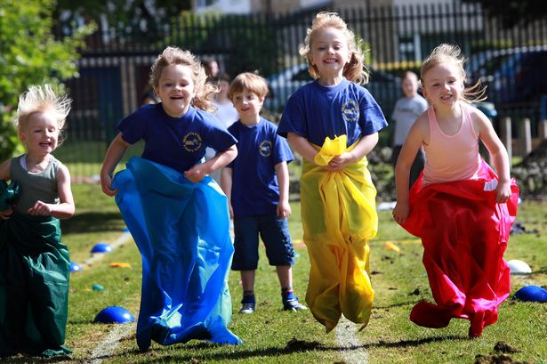

HEALTH AND SPORTS DAY IN JAPAN
Japanese are very keen on sports. They have a national holiday that celebrates sports and it is called Health and Sports Day. It takes place every year in October. Japanese people have been celebrating this day since 1966. Students from all schools in the country take part in the competitions and they organise in teams.
First, the day starts with a parade of all the teams. Then, after group stretching, they compete in events like 100 metre sprint or the long jump. They also have traditional unique Japanese games such as, tama-ire (large teams have 2-3 minutes to throw as many small beanbags as possible into a basket at the top of a tall pole) and o-tama-korogashi (teams of two have to roll a giant ball through an obstacle course).
This day isn`t just for kids. It encourages people of all ages to be active, to stay healthy and to keep fit. There are events inside the schools for parents as well. We have a lot of fun all day!
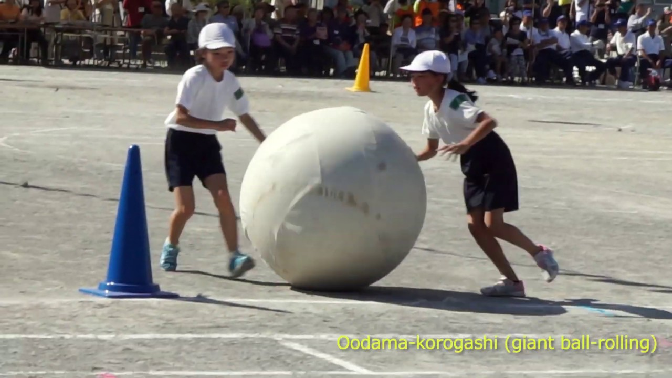

Complete the table with information from the text:
NAME OF THE ACTIVITY | COUNTRY | WHEN DOES IT TAKE PLACE | WHEN DID IT START | WHAT ACTIVITIES/SPORTS

Follow up: Elevii pot fi rugați să urmărească o competiție sportivă (în cazul de față, jocurile olimpice) și să vorbească despre câștigător menționând și de cât timp practică sportul respectiv.

