NECESSITY/ LACK OF NECESSITY:
- HAVE TO;
- DON`T HAVE TO;
- NEED TO;
- NEEDN`T
1. Rewrite the sentences by replacing the bold words with one of the necessity expressions above. Match the activities with the pictures.
a. The entrance at this museum is free so it is not necessary to buy a ticket.
………………………………………………………………………
b. It`s necessary to go to that party and accompany your brother.
………………………………………………………………………………
c. I`ll go shopping with you because it is really necessary to buy a new pair of shoes.
……………………………………………………………………
d. It is not necessary to buy a new bicycle helmet. I can lend you one.
……………………………………………………………………
A. 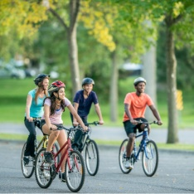 B. C.

D.
֍ Tell one of your team mates something that is necessary/not necessary to do when you are on holiday!

