POSSIBILITY / PROBABILITY
MAY and MIGHT

- Describe the possibility in each situation:

  - There are some bicycles in the park. [may]

The cycling contest may start from the park.

  - It’s nine-thirty and Jack feels tired. [might] 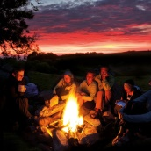

  - We didn`t finish packing. [may not] 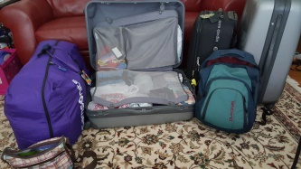

  - Kelly and Jenny are friends, but they live in different cities. They are both travelling to Washington this summer. [may]

  - My brother went out this evening to have dinner in town. [might]
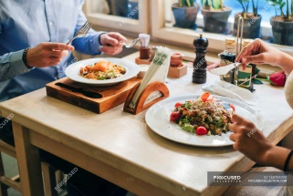

֍ Tell one of your team mates something that is possible to happen next weekend.

