PERMISSION AND REQUEST
- CAN
- COULD
- MAY

- Write the best option to request or ask permission:

  - Tell your mom that you want to go out with your friends tonight.

_

  - In the summer camp, ask your teacher that you want a drink of water.

  - Tell your brother that you want the door opened.

  - You want to ask an elder woman to give you a strawberry ice-cream

Build questions for each situation using CAN, COULD or MAY

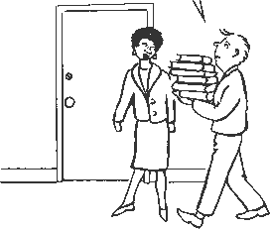
֍ Ask permission from one of your team mates to join them in the free time activity they are doing next weekend

